General Introduction

Physical activity or exercise can improve our health and reduce the risk of developing a number of diseases, such as diabetes, cancer and cardiovascular disease. It can have immediate and long-term health benefits. Most importantly, regular activity can improve our quality of life.

So, as more people realize this important fact, we tend to notice an increase in the number of people attending gyms, or seeking fitness related content online.
When someone chooses online fitness solution, it means that they get to save money, time and achieve the desired goal all in the comfort of your home.

It is in this context that our end-of-studies project will consist of making an application to manage fitness activities. The purpose of this report is to present the approach followed to achieve the creation of a Workout Management Application.

We present in the following the general organization of our report which is organized in four chapter:

- The first chapter, Context and Objectives, is dedicated to the presentation of the host organization Mega-DEV and the general overview of the project, the subject problematics, the description of the proposed solution and the adopted methodology of work.
- The second chapter, Specification and Conception, describes the specification of needs through describing the non-functional and functional requirements in an informal way, an in a semi-forma way through use case diagrams.
- The third chapter, Design and Architecture, focuses on the general design and architecture of the proposed system, as well as providing the class diagram and the sequence diagrams.
- Finally, the fourth chapter entitled Realization presents the tools we used for the development of our project and this report, then we finish by showing screenshots of our application

The report ends with a general conclusion in which we summarize the synthesis of the work done and prospects

Chapter 1 : Context and Objectives

  - Introduction

This chapter will be divided as follows: First, I will present the context of the project and it’s problematic, as well as give an overview of the host company, Second, I will present the solution that I developed after in-dept study of existing solution on the market, then I will specify the work methodology that I will follow through developing the application and a conclusion

  - Internship Context

The work in this report was carried out as part of my end-of studies project to obtain an applied license in computer science at the Higher Institute of Computer science and Mathematics of Monastir. This internship was carried out within Mega dev agency on the subject of: Design and development of a web application that helps users achieve their fitness goals.

  - Presentation of the host company

Mega-DEV is a web design and development company that provides end-to-end development service for web and mobile development.
It was created in 2010 in Houmet-souk, djerba. Since then, it has developed and created several projects for multiple local organization and foreign ones and in different sectors such as health care, Real Estate, travel, E-commerce, Education … etc.

  - Motivation and problematic

Every single person wants to be the best version of himself, everyone just wants to become fit, to lose weight and to build on lean muscle, and we all know how working out benefits your health and reduces stress as well as being an energy source for your body. But not everybody can do it.
Not everyone has a gym nearby or has the time to go to the gym in the first place, and even they did have the time, sticking to going to the gym 3 or 4 time a week can be very challenging as your motivation level decreases over time.
Which is why a need for a solution that helps people work out from home arises.
Such a solution could help millions of people around the globe achieve their dream of becoming fit, it could:
-guide people in their fitness journey without making mistake
-Connect them with other people to stay motivated along the way

In this report, I will present my solution as well as go over some of existing web application that tend to offer a solution to this problem.

  - Study of existing solution on the market

In this section, I will showcase the different solutions available on the market. The main purpose of this section is to find the strong features and drawbacks of these solution so that the development of my project is oriented into making it the best available option for its target users.

Here’s a demonstration of the available web applications that I tested:

    - fitness Blender
Fitness Blender is a fitness platform that offers full-length workout videos, workout programs as well as diet and meal plans. It also provides articles and information related to fitness.
This is being done through their platform which is optimized for user experience

Strong Features
Fitness Blender has some attractive feature such as:

Community page: This is where the trainer post articles about fitness which the user of the website can interact by writing comments and ask questions.
Full-length workout videos: Voice instructions that help with correctly executing the moves and low injury risk due to guidance.
- Content: Fitness Blender has a great selection of videos for any fitness level;

Calendar: this feature allows the clients to set up a remainder of which full-length workout videos to follow and on which date and time.

Drawbacks:
Despite its interesting features, it still has some weak points

-It doesn’t connect users with each other to help motivate and encourage them to stick to their programs until the end. This is crucial since people going through diet often experience undesirable effects of withdraw of certain food such as sugar, having someone to encourage during these difficult times is paramount for success

-It doesn’t show the results of people that successfully finished their programs with noticeable results

-They don’t offer specific programs to specific user while taking consideration the user’s condition such as age, gender and available time

-Workouts and Food plans are bought separately which could prove expensive

In conclusion, fitness blender is easy to use and a good source of multiple types of workouts, but it doesn’t have the features to give selected workouts to selected user, as well as connecting participants together

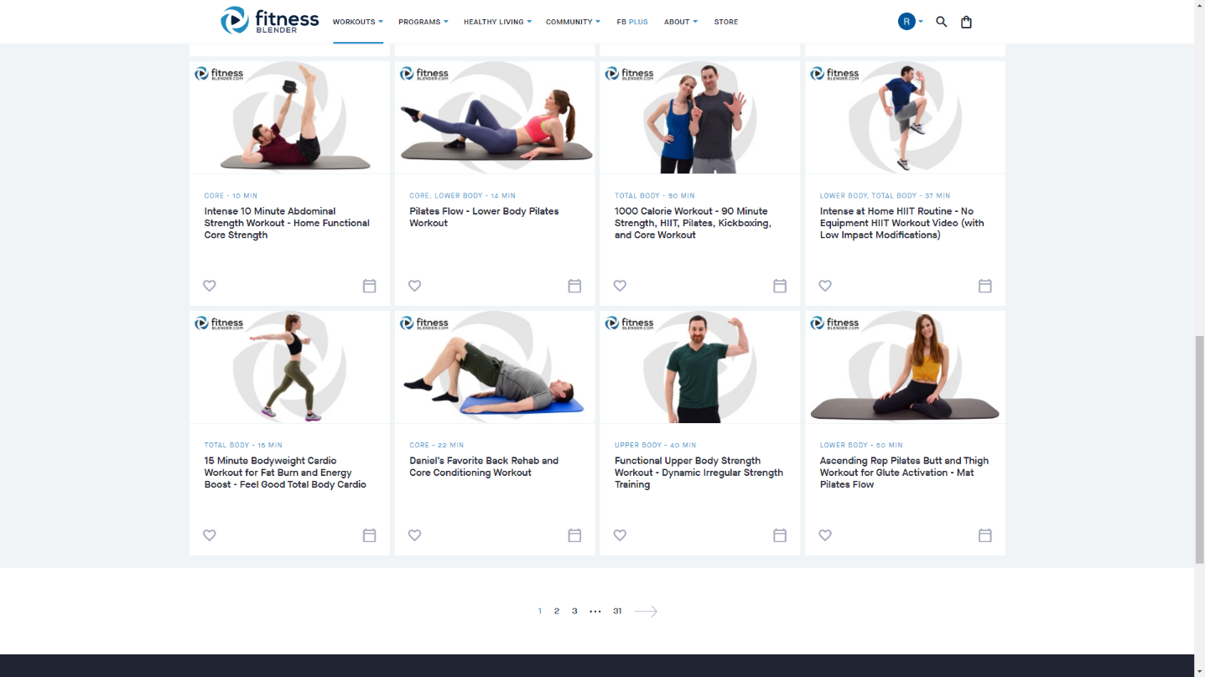

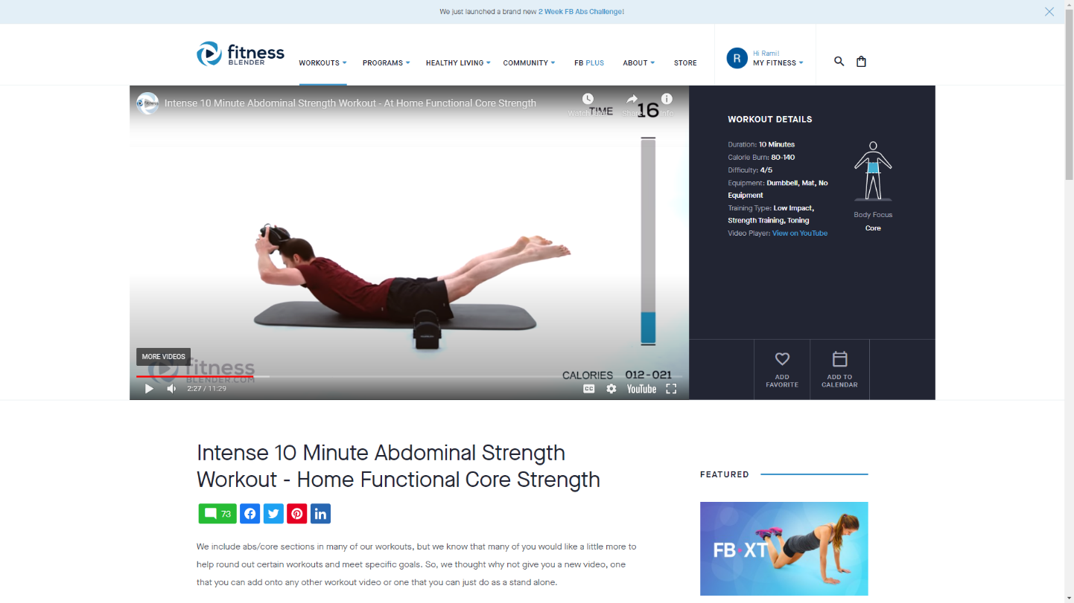

    - BodyBuilding

Originally, BodyBuilding.com is an online retailer of dietary and sports supplement company.
But recently, it has become a great resource for workout plans created by experts. It has a huge database of workout videos which are updated regularly.

Strong features

Among it’s features, BodyBuilding.com offers:
Customizable fitness plans

Step-by-step workout guides

Community where users can interact with each other and share fitness-related information

New content regularly

Drawbacks

Even though BodyBuilding.com offers efficient and dynamic services. There are some weak points.

-It’s mainly a shop, and its main interface is designed to promote their supplement products and equipment.

-Most of their diets and workouts require the user to buy supplements.

-Workout plans are offered to everybody users have to choose the workout plans themselves.

-Most of their workout require gym equipment.

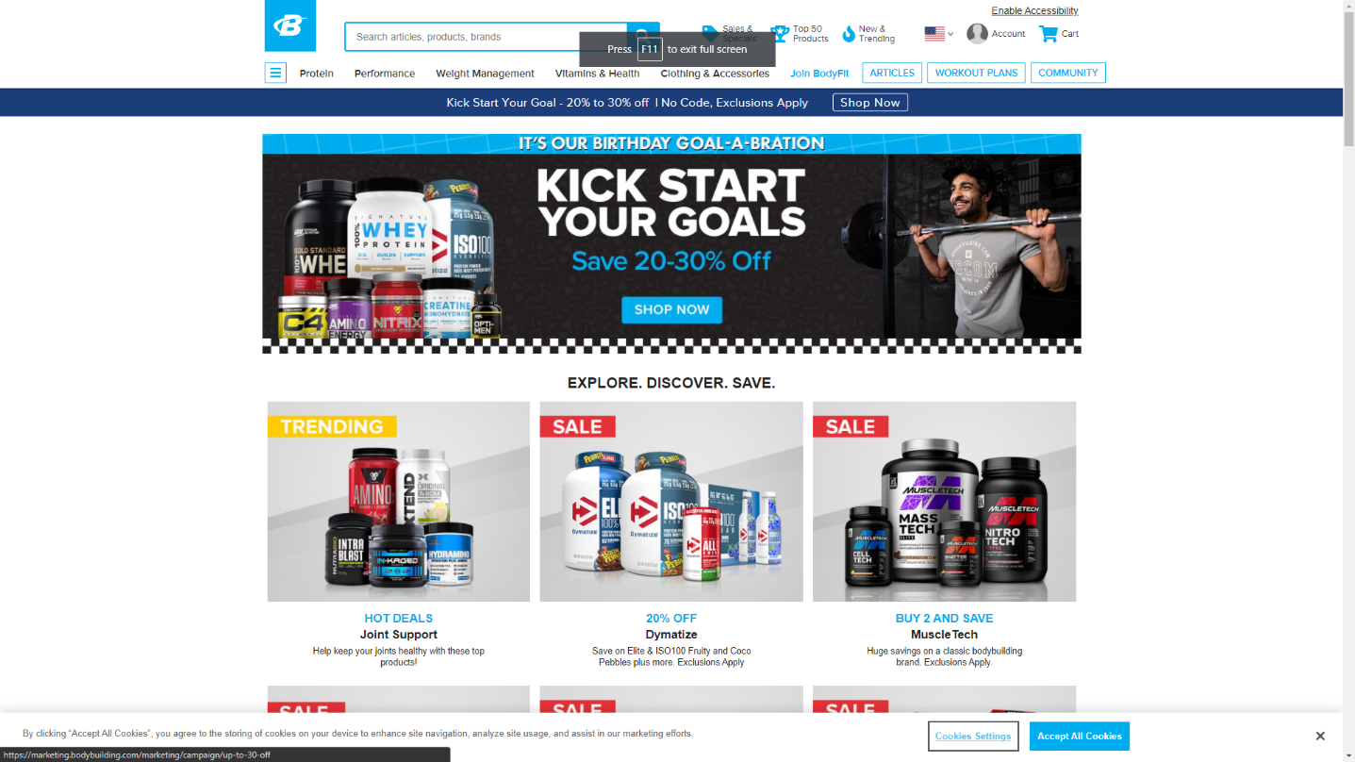

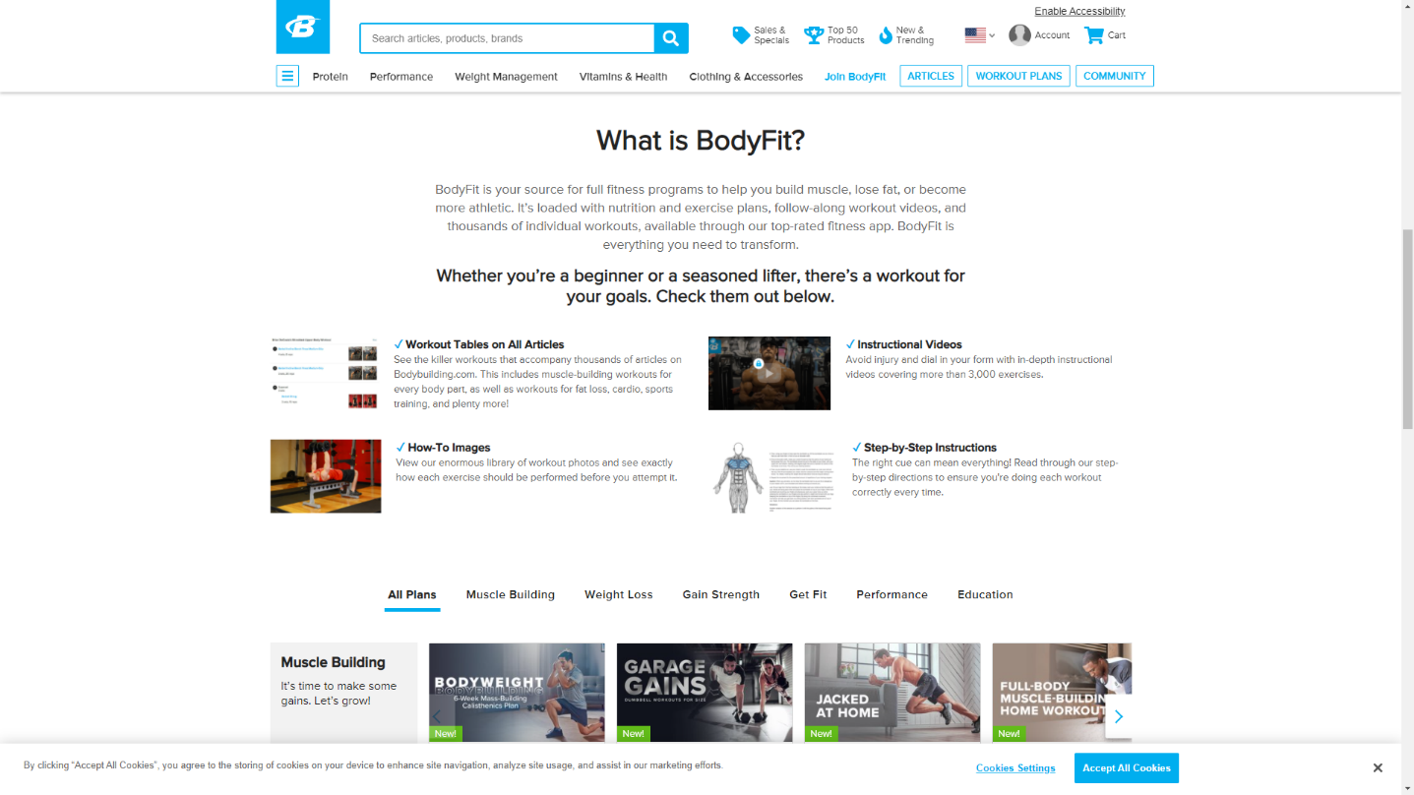

In conclusion, Bodybuilding.com is a great source of workout plans and it isn’t expensive, but the fact that it’s a store for supplements and that it promotes supplements with workout can be confusing to its users.

    - 6weeksixpack
6weeksixpack is basically website that offers a challenge, after signing up, the user receives an email containing the link to the webpage that contains the workout for that day.

Strong features

-the users receive daily emails which keeps them motivated
-each webpage contains a video specific for one day and it doesn’t get sent twice

Drawbacks
-Users can’t see the entire program from the start, they have to wait until the specific day.
-The workouts are only about abdominal muscles, not the entire body.

In conclusion, 6packsixweek doesn’t offer enough workout plans, nor does it connect users with each other, but the fact that users need to tune in each and every day to find out what needs to be done is a huge factor into helping participants into sticking until the end of the program.
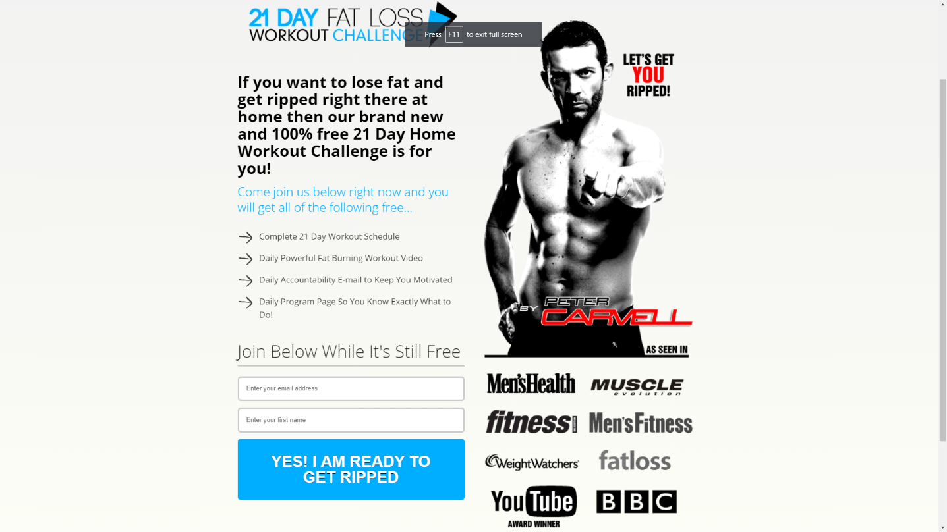
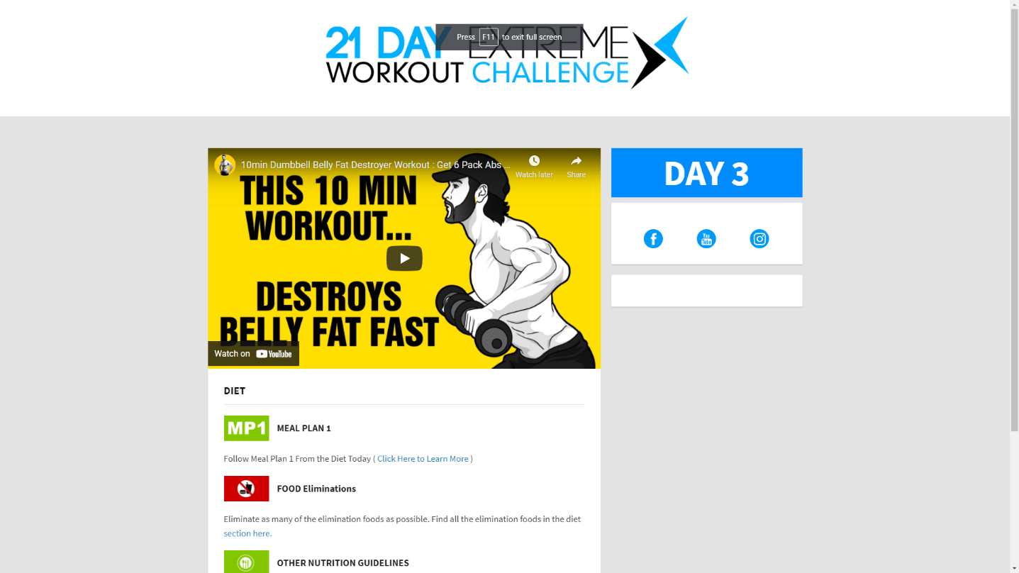

  - Criticism of the existing solutions

In this section, I will move on to the criticism of the existing solutions based on comparative research aimed at emphasizing the advantages that my application will bring.
Even though they’re all fitness application that provide workout plans for its users, they differ in terms of several criteria which are defined as follow:

- Design

- User experience

- Full-body workouts

- Home workouts

- Interaction between users

- Progress tracking

- Assigning workouts while considering their conditions

- Easy to use

Table 1.1 represents the result of a comparative study between the different solutions based on the criteria defined above

 | Fitness blender | BodyBuilding.com | 6weeksixpack
Design | V | x | x
User expericence | v | x | x
Full body workouts | v | v | x
Home workouts | v | v | v
Interaction between users | x | v | x
Progress Tracking | x | v | x
Assigning workouts for specific conditions | x | x | x
Easy to use | v | x | v

  - Our solution

After the project study and researches, we opted for creating a web application that responded to its users in a way that the other existing ones never could.

-Fitness planet is going to be a dynamic and interactive web application that allows creating a fitness program and to track users who are undergoing that program

-Fitness planet is going to allow its user to receive a fitness program that meets their goals, and in the same time takes into consideration multiple factors like user’s age, gender and available time for workout.

-Every fitness program in Fitness Planet will contain all the needed resources such as videos, articles etc.

-It will also allow its users to connect with other users going through the same fitness program in support groups and to compete to be on top of the leaderboard. These groups will provide needed motivation for its users to stick to the program until the end

-This solution will minimize the costs of hiring a personal trainer and help those who want to work out at home instead of going to the gym.

  - Methodologies

The methodology is a rationally organized approach to achieve a result. Among the different existing methodologies, we find the the waterfall approach which is well known to be used in simple projects whose needs are clear and well defined from the beginning, Agile methodologies (Scrum and extreme programming) characterized by their flexibility and used in large project.

1.8.1 Waterfall Approach

The waterfall model is a linear project management approach, where stakeholder and customer requirements are gathered at the beginning of the project, and then a sequential project plan is created to accommodate those requirements. The waterfall model is so named because each phase of the project cascades into the next, following steadily down like a waterfall
The waterfall model has, at least, five to seven phases that follow in strict linear order, where a phase can’t begin until the previous phase has been completed. The specific names of the phases vary, but they were originally defined by its inventor in the following way:

-Requirements: The key aspect of waterfall is that all customer requirements are gathered at the beginning of the project.
-Design: The requirement specifications from first phase are studied in this phase and the system design is prepared
-Implementation: With inputs from the system design, the system is first developed in small programs called units, which are integrated in the next phase
-Integration and Testing: All the units developed in the implementation phase are integrated into a system after testing of each unit
-Deployment: once the functional and non-functional testing is done, the product is deployed in the customer environment or released into the market.
-Maintenance: The customer is regularly using the product during the maintenance phase, discovering bugs, inadequate features and other errors that occurred during production. The production team applies these fixes as necessary until the customer is satisfied.

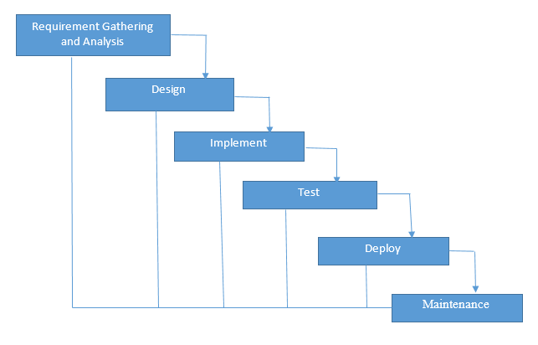

1.8.2 Scrum

Scrum is an agile development methodology used in the development of Software based on an iterative and incremental processes. Scrum is adaptable, fast, flexible and effective agile framework that is designed to deliver value to the customer throughout the development of the project. The primary objective of Scrum is to satisfy the customer’s need through an environment starts from a general idea of what needs to be built, elaborating a list of characteristics ordered by priority (product backlog) that the owner of the product wants to obtain.

The framework is based on the division of a project in time boxed, called “sprints”. Sprints can last from a few hours to a month (with a two -week preference). Each sprint begins with an estimate followed by operational planning. The sprint ends with a demonstration of what has been completed.

The Scrum methodology is easily explained by the figure below.

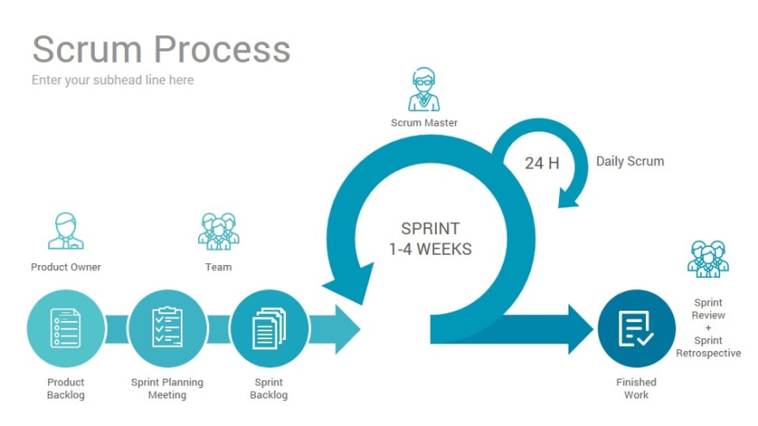

The basic principles of Scrum are the following:
-Determining the functionalities needed in order to create the backlog of the product
-Defining the priorities of the functionalities and choosing which ones will be carried out in each iteration
-Work on the functionalities in iterations called Sprint
-Each sprint always delivers a functional partial product called increment

Scrum Roles

- Product Owner: This person is responsible for defining the work and then prioritizing those tasks. They are clear on the goals of the project, as well as those of the customer market and organization.
- Scrum Master: He plays the role of facilitator and guardian of the correct application. He is a product owner service. He facilitates interactions between members of the Scrum team. He acts on the development process (development definitions of the duration of sprints, the agenda of scrum meetings ...)
- Development team: the development team is the heart of the scrum team, as they’re the ones responsible for doing the actual project work. Each member of the team has a skill that, together with other team members, combines to tackle all the needs of executing the project.

Our choice
We chose the Scrum Methodology as it is the closest methodology to how we planned our tasks and timeline.

2.0 conclusion
In the chapter ,we presented the host company as well as the general context of the work, followed by a study of the existing solution that are close to our application, and we defined our work methodology and finally we described the different technologies used in this project.

